

DOCUMENT TITLE | REVISION
SR8 Steering Conceptual Design | 0

Created By | Date
James Appleton | 21/10/2022

Department | Subsystem
Vehicle Dynamics | Steering

REVISION HISTORY
Rev. | Change Log | Author/s | Date
0 |  | JA  Sumedh Suraparaju | 22/10/21

Contents
Projects 3
Project Scope 3
Responsible Departments 3
Secondary/Supporting Departments 3
Project Interfaces 3
Assigned Team Members 3
Design Factors 3
Lifecycle Analysis 3
Risk Analysis 3
Innovation Analysis 4
Manufacture and Procurement Plan 4
Design and Production Plan 5
Cost Analysis 5
Educational Outcome Analysis 5
Upskilling Development 5
Requirements 5
Functional requirements: Normal Operation 5
Performance Requirements: Teamwide Specifications 5
Interface Requirements: Project/System Interfaces 6
External Requirements 6
References 9

Projects

Project Scope
The scope of this project involves an in-depth analysis and production surrounding the overall steering system present in a car. This specifically includes all the subsystems involved in the steering of a vehicle and all relevant interconnected systems.

Responsible Departments
Vehicle Dynamics (Responsible)

Secondary/Supporting Departments
Vehicle Dynamics – Braking, Suspension, Wheels
Interior

Project Interfaces
Steering Wheel – Interior will be responsible for the design of the steering wheel, with a combined responsibility for integration.
Wiring – Work with embedded systems to best identify wiring path through the steering wheel.
Spacing – Work within design constraints provided by chassis and bodywork.

Assigned Team Members
Sumedh Suraparaju – Steering Team Member (Coordinator)
James Appleton - Steering Team Member
Depending on recruitment numbers and interest, the team will be interested in 1-2 new members over the lifecycle of the project.
Interior liaison – Oliver Wan

Design Factors

Lifecycle Analysis
Necessity of Material | As we intend to use an existing drive by wire steering rack and actuator from a company like Schaeffler, so choice of the material will be dictated by the component manufacturer.
Material Recyclability | Since the intended system consists of two purchased steering racks material recyclability would not apply.
End of Life Disassembly | At the end of the vehicle's life, the steering rack actuators could be removed from the vehicle and reused (provided the next vehicle has the same width).

Risk Analysis
Failure Points of Design | Points of failure would include:  - Failure of steering actuator, where it no longer moves to the desired steering angle given a certain input signal  - Faulty transmission of the signal to the steering actuators  - Faulty processing of the input signal. For the front steering actuator this signal will be a linear transformation of the measure input signal at the rear. Though for the rear this would involve more complicated transformation so that the steering is in-phase and counter-phase at the desired times  - Steering system power failure, if all power is lost to the steering system then they system would become unresponsive. This should be mitigated by having a separate emergency power/battery system for the steering system that would be used only to allow the driver to safely come to a full stop. (This is also and ADR requirement).
Project Delay | - Cost research. Communicating with the industry regarding enquiries on their products has significant hurdles. Approximations can be made through certain inferences and price matching with similar known products. However, in gaining an accurate insight into pricing may take a prolonged period of time conversing with chosen companies.  - MITIGATION & ESCALATION.  - In order to curb this delay numerous emails must be sent to a range of industry manufacturers in order to gauge a price range, with any industry barriers escalated to Richard.  - Part availability. Choosing the best solution in industry in optimal, however certain companies may not provide products for a project that is not on a commercial industrial scale.  - MITIGATION.  - Emailing companies and gaining a better understanding of supply, early in the design process, will reduce the risk of part availability.  - Part integration. Integrating a completely new steering setup and liaising cross-department to appropriately integrate connected parts may cause delays if not aptly planned beforehand. Further, within the steering system itself, despite the best effort to ensure all parts purchased/manufactured function optimally in combination, issues may develop with further optimisation required.  - MITIGATION.  - Liaising with other departments within Sunswift such as Interior for the steering wheel and wiring early in the design process will prevent incompatibilities.  - Shift in prioritisation. A change in priorities in terms of design vision will alter the steering system.  - ACCEPT.  - Research into multiple feasible systems, selecting the most appropriate one, whilst keeping alternatives with unique advantages in mind.  - Overengineering and overestimation. The proposed steering setup is a complete overhaul and integrates a relatively new technology at its core. As such attempting to accomplish to integrate numerous cutting-edge technologies with limited information has the potential to pose significant issues.  - MITIGATION.  - In order to prevent the overestimation of capabilities and integration, a clear path of prioritisation must be set with backup simple solutions for innovative areas.
Identification of Unknowns | - ADR’s and lack of overall clarity regarding drive by wire.  - MITIGATION. ELEVATION  - Conduct in depth research into ADR’s and raise any concerns.

Innovation Analysis
Innovation would rank as medium as all wheel steering is has never been done before by Sunswift, however it is present is some, though very few, cars on the market like the Porsche 911 [1]. Its risk would be low as the all wheel steering method we are looking to implement have been proven in on market cars, its low prevalence is not due to it being too hard to implement but it being generally too expensive to be viable in mass production vehicles.
Similarly, drive by wire is present in some cars on the market, but has never been used by Sunswift before so it would also have a medium rank for innovation. The steer-by-wire components we would use would likely come from Bosch or a similar manufacturer, so the risk of failure would be very low due to the testing and validation that would be performed prior to us ever receiving the part.
So both the all wheel steering and steer-by-wire technologies would have the same
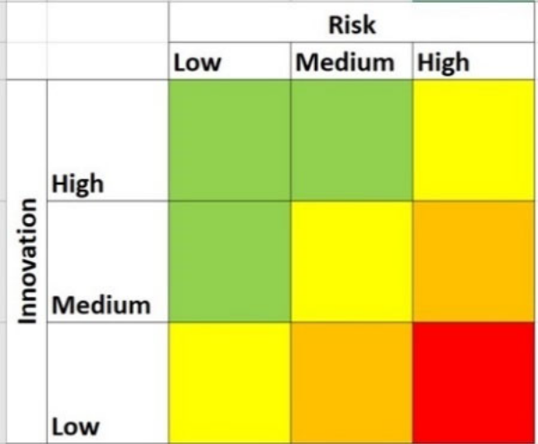

Manufacture and Procurement Plan
- Bosch.

Design and Production Plan

Cost Analysis
Costing of the drive by wire system is very difficult as even when asking Bosch, they would not provide any indication of cost.
It can be assumed that a steer by wire steering actuator would be significantly more expensive than a traditional mechanical steering rack. To achieve all wheel steering at least one steering actuator is required to control then rear steering. The front steering could be either
Again, this is hard to justify without

Educational Outcome Analysis
External procurement is the only feasible approach for drive-by-wire due to overt safety constraints and required redundancies. However, the interconnected components of the steering system have potential for in-house manufacturing, subject to industry supplying interest. Manufacturing a steering wheel in-house is entirely feasible and enables full customisation of buttons and wiring as a benefit. The steering column will not be able to be built in-house as for a drive by wire system there will need to be feedback motors and angle sensors at the bottom built into the steering rack. There is possibility for modification of the steering column for wiring constraints, subject to the restrictions imposed by the selected model. The variable steering ratio will be apart the drive-by-wire system and will be pre-built with minor room for modification. The steering rack and integrated components will be sourced if possible and modified to necessary requirements, but will also have the capability to be manufactured in house.
Overall educationally, integration of cutting-edge systems and necessary modifications will be the primary factor, with in-house production using workshop skills as a secondary factor.

Upskilling Development
Welding will be an important upskilling requirement in order to produce/modify larger parts, including an Ackermann steering geometry, in-house.

Requirements

Functional requirements: Normal Operation
The normal operation of the steering system is to provide steering control of the vehicle via all wheel steering in response to steering inputs.
At low speeds, nominally less than 35 km/h, steering control will be through counter-phase steering. This consists of the front and rear steering in opposite directions to reduce the turning circle of the vehicle.
At higher speeds, nominally greater than 35 km/h, steering control will be through in-phase steering. This consists of the front and rear steering in the same direction to increase the stability at higher speeds.

Performance Requirements: Teamwide Specifications
The all-wheel steering system should provide a reduced turning circle during counter-phase steering at low speeds (<35 km/h), and increased stability at higher speeds during in-phase steering (>35 km/h).
These improvements should translate into better vehicle handling and lower lap times.

Interface Requirements: Project/System Interfaces
There are two interfaces for the steering system with the electrical/embedded systems: the interface at the input device (steering wheel for example, though it could be any device), and the interface at the steering rack actuator.
The interface the input device is where the driver’s steering input is measured (via a potentiometer for example). This measured signal is the interface with embedded/electrical systems, which will perform the required transformation to this signal to get the front and rear steering actuator signals. These new signals are returned at the interfaces with the front and rear steering actuator.
The interfaces at the front and rear steering actuators will occur at the controllers for each respective actuator. It should be noted that the signal to the front and rear controllers will be different so this should constitute two separate interfaces: front controller, and rear controller.
Steering will interface with frame/subframe at the mounting points for the steering actuators, will likely consist of 4 bolts per steering actuator which will need to be fastened to the frame/subframe.

External Requirements
The primary external requirements are the Australia Design Rules (ADRs). The set of ADRs that govern steering are Australian Design Rule 90/00 – Steering System. The following are the requirements for a steering system.
- Failure of any non-mechanical component of the steering system must not prevent effective steering of the vehicle.
- Vehicles with ‘full power steering equipment’ must be capable of providing steering failure and defect visual warning signals to the driver. Category LB, LD, LE, MA, MB, MC, MD, NA and NB1 vehicles must have a ‘turning circle’ in either direction, as determined according to the definition in paragraph 2.4.6 of Appendix A, not exceeding 12 metres in radius. In the case of category ME, NB2 and NC vehicles, the extreme outer edge of the tyre track at ground level, must be capable of turning in either direction within a circle with a 12.5-metre radius. Category M and N vehicles, which meet the requirements of Appendix A as varied by Section 6 Exemptions and Alternative Procedures, will be deemed to comply with this rule.
Below table detailing the relevant sections from Appendix A and therefore must be complied with.
Section | Section Number | Description
Scope | 1.1. | SR8 is type M, so the following regulation do apply
Scope | 1.2. | We do not meet any of the exemptions for this regulation
Definitions | 2.3. | Definitions for steering what constitutes steering equipment.
Definitions | 2.4. | Definitions for steering parameters (steering angle, turning radius, etc.)
Definitions | 2.5.1. | Defines main steering system
Definitions | 2.5.1.1.3. | Define full power steering. This is the type of steering system that steer-by-wire would fall under
Definitions | 2.5.1.3. | Defines Auxiliary Steering Equipment. This is what the rear wheel steering is considered as.
Definitions | 2.6. | Define types of steering transmission
Definitions | 2.6.3. | Define purely electric steering transmission. This is what drive by wire would be.
Application for Approval |  | N/A
Approval |  | N/A
Construction Provisions | 5.1. | Provides general benchmarks and provisions that must be satisfied
Construction Provisions | 5.1.3. | Does not apply to either ASE, or full power steering (which SR8 would be consider as both)
Construction Provisions | 5.1.4. | Provides that for failure test cases, it can be assumed that only one failure will occur at any given time
Construction Provisions | 5.1.9. | The steered wheels shall not be solely the rear wheels, this may affect the main requirement justification set out below.
Construction Provisions | 5.3. | Failure provisions
Construction Provisions | 5.3.1.1. | Mechanical components can be assumed to not fail (assumed not liable to fail).
Construction Provisions | 5.3.3. | Failure for full power steering
Construction Provisions | 5.3.3.2. | In case of failure, it must be possible to steer with the performance from 6.2.5. (as per 5.1.4. only one failure in steering system needs to be considered).
Construction Provisions | 5.4. | Provisions for warming indicators
Construction Provisions | 5.5. | Provisions for technical inspection of the system
Test Provisions | 6.1. | General Provisions
Test Provisions | 6.2. | Provisions for motor vehicles
Test Provisions | 6.2.6. | Table shown below detailing steering control requirements
Conformity of production |  | N/A
Penalties for non-conformity of production |  | N/A
Modification and extension of approval of the vehicle type |  | N/A
Production definitively discontinued |  | N/A
Transitional provisions |  | N/A

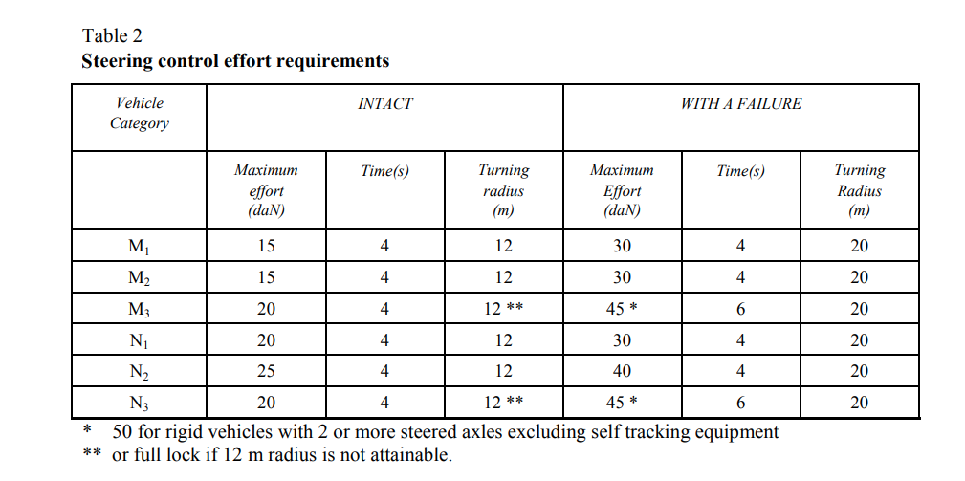
Finally, concerns of compliance were raised with requirement 5.1 “Failure of any non-mechanical component of the steering system must not prevent effective steering of the vehicle” as we intend on using complete steer by wire. The following is a justification as to how we still satisfy this requirement.
As defined in the ADRs, drive-by-wire would be considered as Full Power Steering (2.5.1.1.3). It is provided that only one failure of non-mechanical systems can be assumed to occur at any given time (5.1.4) for the purpose of section 5.3.3.2. As we intend on implementing all wheel steering, if the front/rear steering fails then the other can still provide steering control. The worst case would be if the front failed as the steering angle of the rear would not be greater than about half the angle at the front. Therefore, if the turning circle has a radius less than 20m when only steered by the rear in the case where the front steering fails, the car would still have effective steering. Hence 5.1 would be satisfied.

References

[1] | J. Barnett, “TECHNOLOGY EXPLAINED: REAR-AXLE STEERING,” [Online]. Available: https://www.total911.com/sales-debate-how-much-further-will-porsche-997-prices-fall/.

